Life Science Unit
Visions into Practice Task: Demonstrating Science Knowledge
Our task is to “examine offspring in plants that are produced sexually. Note and record variations that appear. Determine how the variations may help an organism to survive if the environment should change (e.g. warmer or cooler temperatures, increase or decrease in precipitation).”
We will complete this task in 3 steps.
Step 1: Pictures of Poppy Flowers
Look at each picture of a flower bed consisting of poppy plants. In all cases the seeds were produced sexually from the previous year’s poppy plants and came up from seeds that wintered over from last year.
Do you notice variations in the individual poppy flowers within the group? What are some of them?

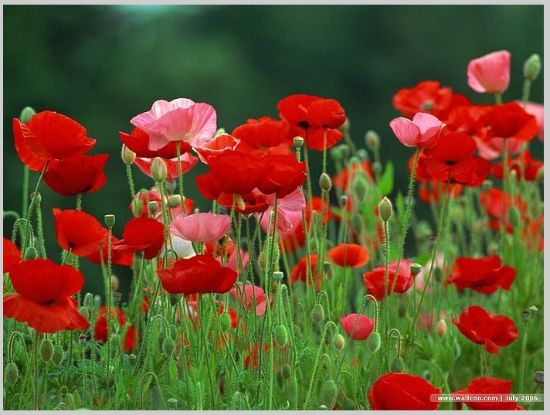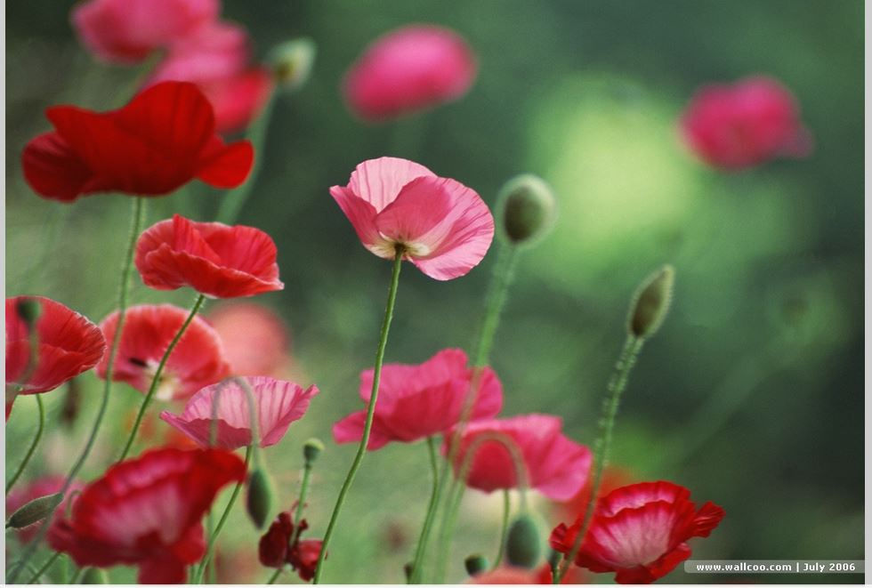
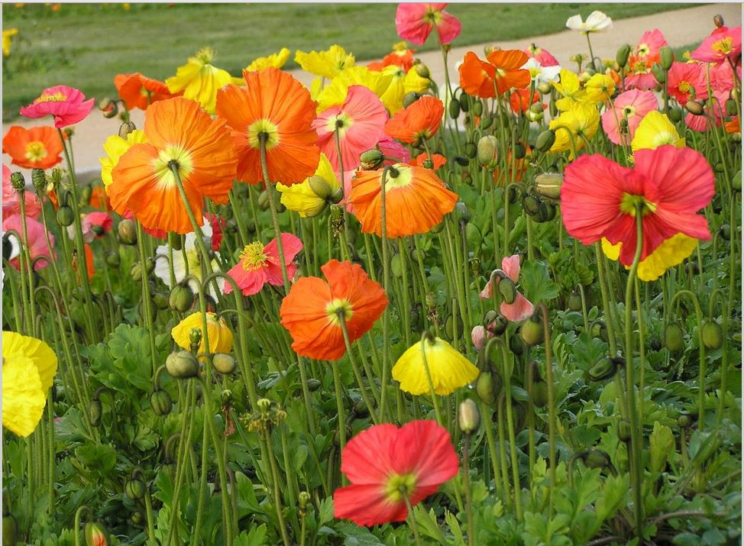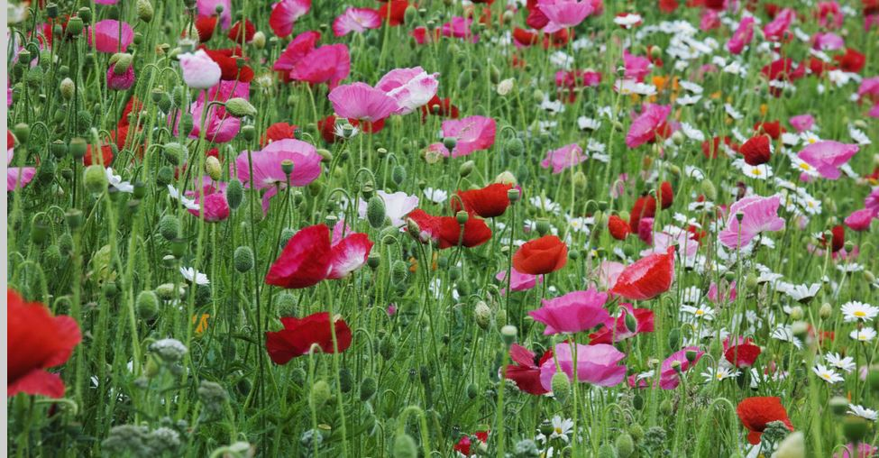

Step 2: Here’s the Problem with Poppies
Seeds from this year’s poppy flower crop will fall to the soil, winter over, and sprout up the following year. In the second year, all flowers may not resemble the previous year’s flowers. There is more variation in the type of poppy flowers you have now. If you let it continue for another year, next year’s flowers may not seem as fancy as the first year you planted them, with more and more types of plain flower types popping up.
Discuss with a classmate why you think this happens. Be ready to share some of the ideas in class.

Step 3: Discover the Answer from an Expert
The following excerpt is an actual “Q & A” where a person asked an expert for help on how to restore only certain fancy poppies in her garden year after year.
Read the full article on the next page and summarize one of the reasons why variation keeps increasing year after year when they are allowed to seed themselves and summarize one way you can prevent this. (Exit ticket)

