Non-Contact Forces – Lesson Notes
1. Two objects can exert forces on each other without touching.
A. Field Models can be used to explain how this happens. There are 3 kinds: Electric, Magnetic, and Gravitational
- Electric Field Model - Electric fields exist around objects with charge.
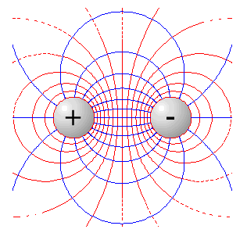
  - What if there are two objects? - If a second object with charge is placed in the field, the two objects experience electric forces that can attract or repel them.

These two will attract.
These two will repel.

  - Electric force weakens rapidly with increasing distance.

- Magnetic Field Model – Magnetic fields exist around magnetic objects.
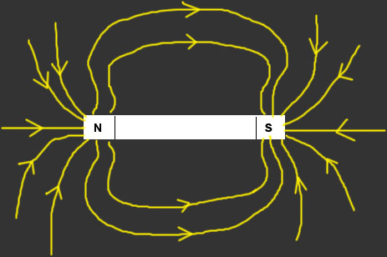
  - What if there are two objects? - If a second object is placed in the field, the two objects experience magnetic forces that can attract or repel them.
These two will attract.
These two will repel.
  - Magnetic field lines can be seen when iron filings are sprinkled around a magnet:
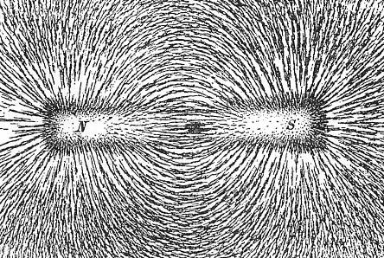
  - Magnetic force weakens rapidly with increasing distance.

- Gravitational Field Model – Magnetic fields exist around objects with mass.
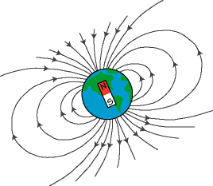
  - What if there are two objects? - If a second object with mass is placed in the field, the two objects experience attractive gravitational force toward each other.
Example: Earth and Moon
  - Every object with mass exerts a gravitational force on every other object with mass. The forces are hard to detect unless at least one of the objects is very massive.
  - Gravitational force increases with the mass of the objects, decreases rapidly with increasing distance, and points toward the center of objects.
  - Weight is gravitational force and is often confused with mass.
2. Electricity is related to magnetism.
A. In some circumstances, magnetic fields can produce electrical currents in conductors (metals). Electric currents produce magnetic fields.
B. Electromagnets are temporary magnets that lose their magnetism when the electric current is turned off.
C. Motors and Generators have magnets and a coil of wire that creates its own magnetic field when an electric current runs through it.
1. Electric motors convert electrical energy into mechanical energy (blenders, washing machines).
2. Generators convert mechanical energy into electrical energy (power plants).

