Name, Date, Period:______________________________________________
Lab Test: Non-Contact Forces – Electrical and Magnetic
This test has a time component, so you must work efficiently and cooperatively. YOU MAY CONFER WITH YOUR LAB GROUP, BUT YOU MAY NOT COPY. Remember to turn off the switch to save battery life. Always disassemble one lab test before starting the next one. Keep things in order and neat at all times.
Lab Test A
Purpose: to create magnetism through electricity.
Directions and Questions:
- Set up a circuit that looks similar to the image below.
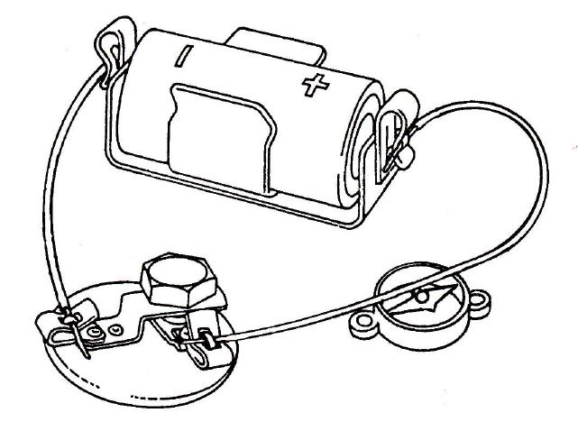
- Place the compass under the wire so that the wire runs in the same direction as the needle is pointing. You may have to bend the wire to do this.
- Wait a moment for the compass needle to settle down, then turn the switch on carefully.

- What happens when you turn the switch on and why? _____________________________________________

__________________________________________________________________________________________
- Turn the switch off. What happens when you turn the switch off and why?
______________________________________________________________________________________________
- Does this work for the other wire(s) in your circuit? Test it out and state what you found out: ______________
_____________________________________________________________________________________________
- Test to find a situation that changes the way in which the compass acts. Explain what you did and what

happened to the compass: ___________________________________________________________________
_____________________________________________________________________________________________

Lab Test B
Purpose: making a magnet with electricity.
Directions and Questions:
- Set up a circuit that looks similar to the image below, making sure the battery is placed properly:
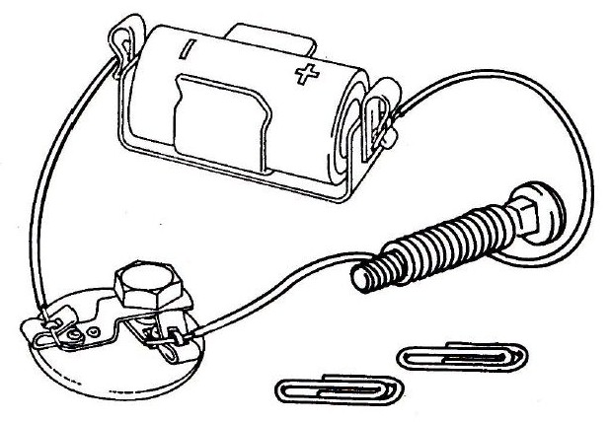
- What you have built is a type of electromagnet. Test to see if you can make your electromagnet pick up and drop paper clips by turning the switch on and off. State the results of your test here:
___________________________________________________________________________________________
- Use the compass to determine which end of the electromagnet is the north pole and which is the south pole. Remember: the north needle of the compass is attracted to the south pole of the electromagnet and vice versa! Each person must test this on your own and come up with your own answer. Fill in your answers below:
The top of the bolt is the ____________________ pole of the electromagnet.
The bottom of the bolt is the ___________________ pole of the electromagnet.

Lab Test C
Purpose: to test a variable that affects the strength of an electromagnet.
Directions and Questions:
- Some variables that can affect the strength of an electromagnet are the number of turns of wire, the number and/or sizes of batteries, and different kinds of wire. Decide with your group one variable to test.

- What variable are you testing? ________________________________________________________________

- Create your own hypothesis about the variable your lab group is testing: _______________________________

_______________________________________________________________________________________________

- Set up and conduct a three trial experiment that demonstrates 4 levels of electromagnet strength: none (control), weak strength, medium strength, and high strength. Number of washers lifted by the magnet can be used to reflect how strong the electromagnet is.
- Construct a neat data table in the space below that includes headings and all of your recorded data. Each person must make your own data table by yourself.

- Construct a bar graph of your data in the grid below. Label axes and title your graph. The independent variable (that which you tested) needs to go on the x axis (bottom) and the dependent variable (strength of electromagnet) needs to go on the y axis (the side).

- What is your conclusion about how your variable affects electromagnetic strength? _____________________
____________________________________________________________________________________________
Lab Test D
Purpose: to generate electricity. (No battery!)
Directions and Questions:
- Here is a view of the materials you will be using for this lab:
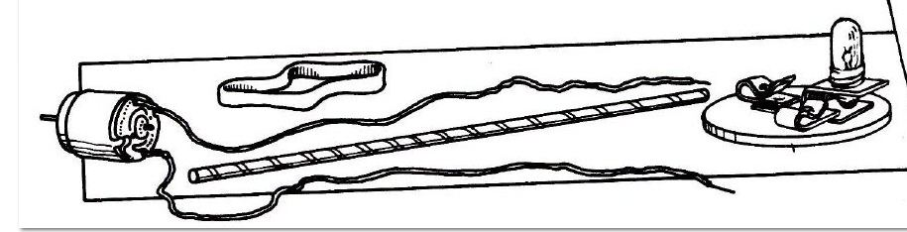

- Hook up the motor to the bulb. After they are hooked up, does the bulb light – yes or no? _____________

- Try turning the motor with your fingers while watching the bulb. Will this make the bulb light – yes or no?
- Wrap the rubber band around the edge of a book as shown in the image below:
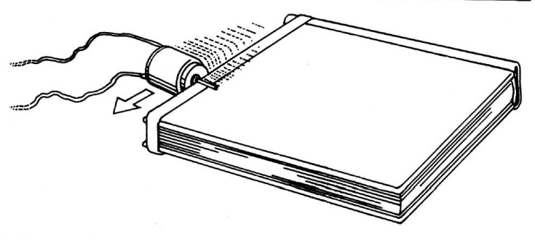
- Rub the motor shaft on the rubber band to make the motor turn fast. Can you make the bulb light by this method – yes or no?
- When a motor is used like this to make electric current flow, it is called a generator.
- Explain the energy conversion that was involved in making the generator able to turn on the light in this lab.
_____________________________________________________________________________________________
- Brainstorm and write down at least two different ways you can think of to turn a generator on a larger scale
(in order to produce electricity for a whole community of homes):
____________________________________________________________________________________________
Extra If Time
After turning in your test, you may complete the following experiment if there is time:
- Disconnect the bulb from your motor. Connect your motor directly to another group`s motor, as shown below. Take turns making the motors spin. Attach a straw to the motor shaft so that you can see it turn.