Type of Geologic Activity | Type of Boundary or Boundaries | Picture(s) and Link(s)
1. Volcanic Activity | a. For Rift Volcano:  ____________________________  b. For Hot-spot Volcano:  ____________________________  c. For Subduction Volcano:  ____________________________ | http://kids.britannica.com/comptons/art/print?id=156130&articleTypeId=0  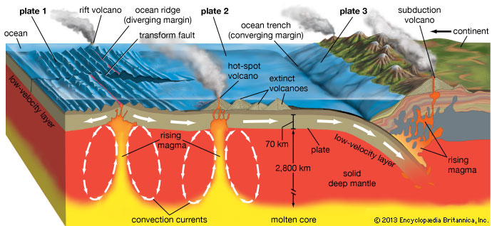
2. Earthquakes  2. Earthquakes continued | a. The first type of plate boundary where earthquakes are prone to happen is:  ___________________________  Specifically, at the  __________________________  zone.  b. The second type of plate boundary where earthquakes are prone to happen is:  ____________________________ | 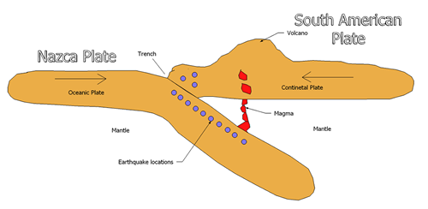  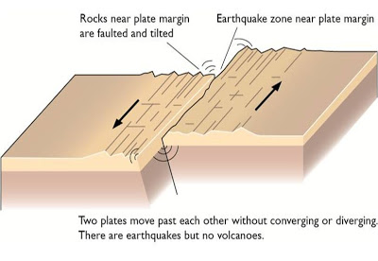  http://geotectonics.blogspot.com/
3. Tsunamis | This happens at this boundary type:  ____________________________  particularly at the  ___________________________  zone where the lighter plate may ‘snap upward’. | 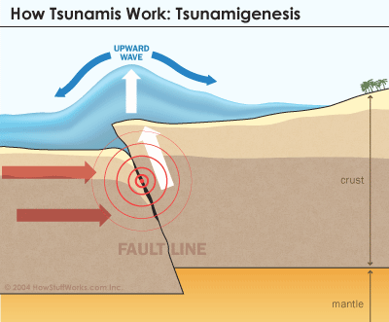  “In some cases of subduction, part of the seafloor connected to the lighter plate may "snap up" suddenly due to pressure from the sinking plate.”  From http://science.howstuffworks.com/nature/natural-disasters/tsunami2.htm
4. Geysers | The heat source for a geyser comes from volcanic magma. Geysers can form in association with volcanoes. Thus, anywhere a volcano can form, a geyser can be an outcome as well as long as there is enough rainwater and the rock is porous enough.  Look back at 1. Volcanic Activity to rediscover the type of plate boundaries that are involved. | 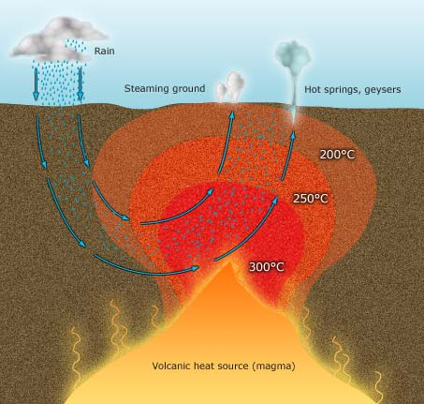
5. Hot springs | Hot springs are pools of warm water that, like geysers, get their heat source from the magma of a volcano. | Use the same diagram as above.
6. Faults | Faults can be caused at any type of boundary due to compression, shearing, or tension stresses that result from all the force. | 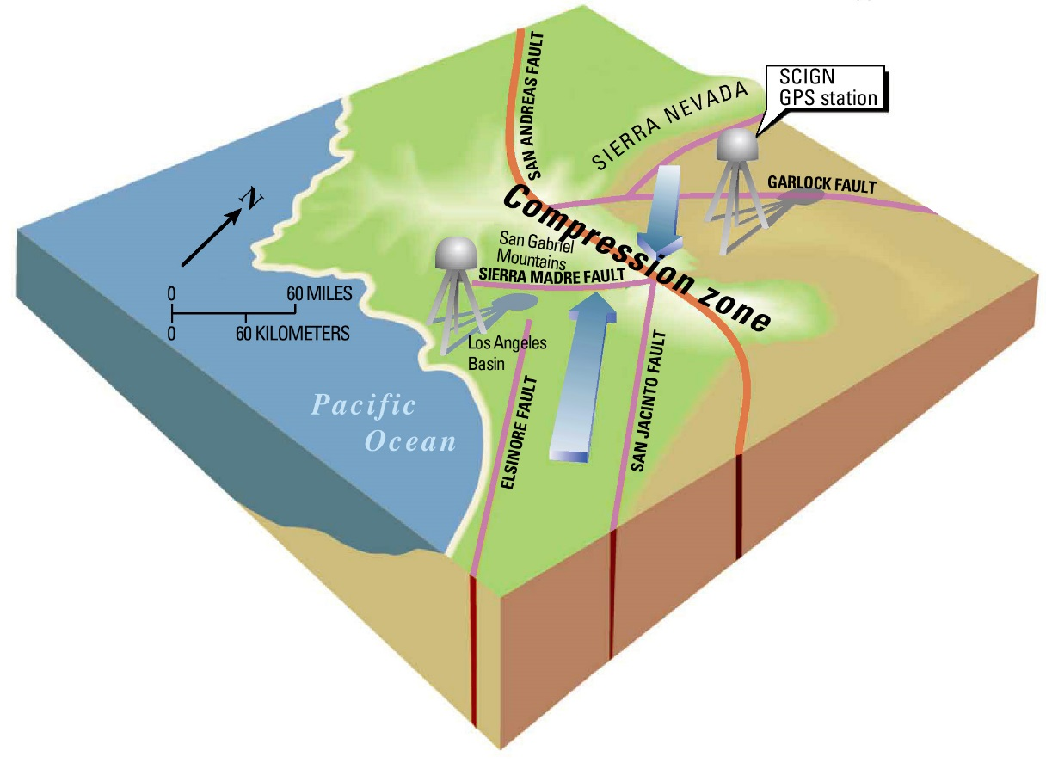  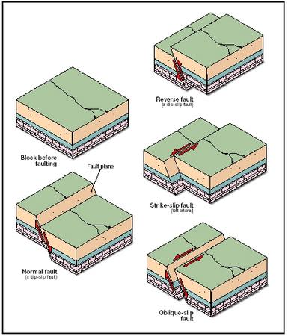
7. Oceanic Vents | This site explains it ---------------  It can be from both  ____________________________  &  ____________________________  Boundaries. | http://oceanservice.noaa.gov/facts/vents.html  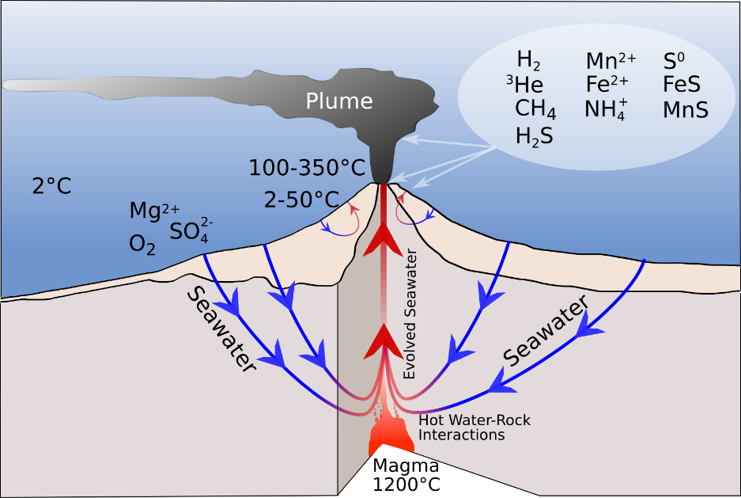
8. Island Arcs |  | 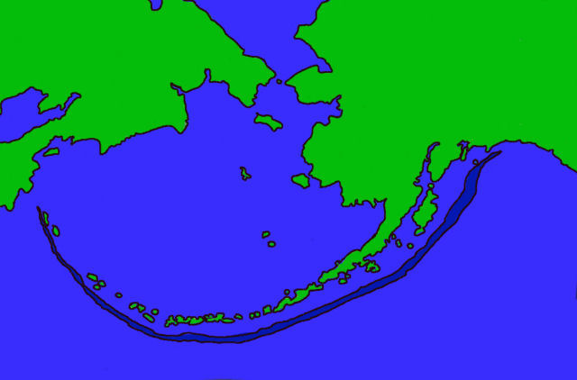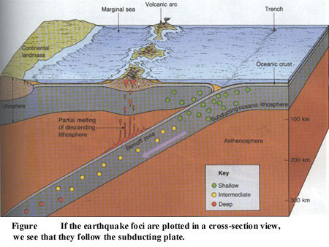
9. Hot spots | Hot spots are still being studied. What they think is that region of molten magma within the mantle exists in a pocket underneath oceanic crust or continental crust. It erupts every now and again while the plate moves above it. It is NOT associated with any type of plate boundary. Examples of volcanoes formed by hot spot magma eruptions are the Hawaiian Islands and the Volcanic features at Yellowstone National Park. | 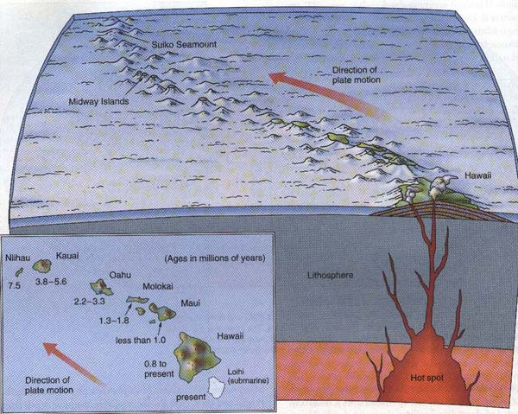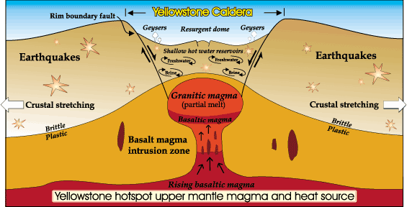
10. Rift Valleys | Rift Valleys are ONLY found at  ____________________________  plate boundaries.  The separation of the two plates is what creates the rift. Often the block of rock at the center drops downward.  There are many, many examples of rift valleys over the world. | 